**Workout plans**

**1.Wenning wrist flicks**

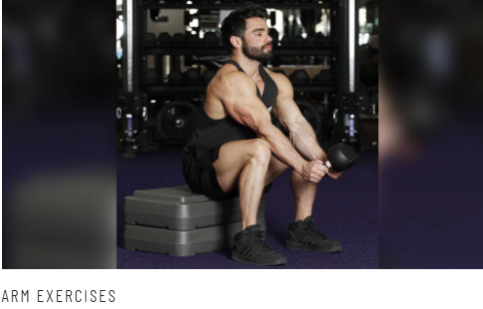

**The setup for performing the wenning wrist flicks is you need to imagine that you lock the flexed elbow at 90 degrees and perform a handshake motion at the wrist, with an open hand and neutral grip. When you point your fingers up and your thumb toward you, this is known as radial deviation. The opposite motion (in which you point your fingers down) is called ulnar deviation, and these movements are a great way to think of this next exercise. Sit on a bench with your forearms wresting on your thighs so that your wrists are free to move. Grab a kettlebell by the horns with a neutral grip so that it is inverted. This is the radially deviated starting position from which you begin the eccentric portion of the rep.**

**2.Behind the back wrist curls**

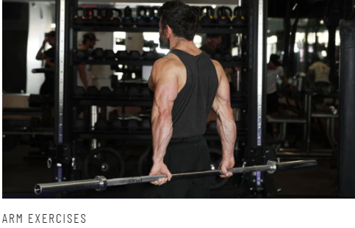

**To setup yourself for the Behind-the-Back Wrist Curl exercise first rack a barbell just below waist height and face away from the bar. Turn your palms toward the bar (i.e., pronate them), back yourself into the bar to grab it, brace your core, and unrack the barbell. The movement begins with your wrist in line with your forearm (i.e., straight), from which you perform a concentric wrist flexion.**

**3.Treadmill press**

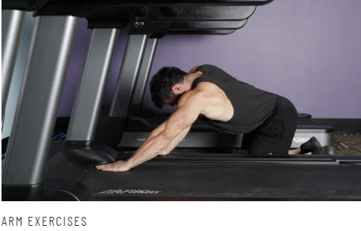

**For the treadmill press while standing on the treadmill, set it to one mile per hour or slower and carefully step off without changing direction (as though you were running on the belt), and set up in quadruped stance (i.e., on your hands and knees). Place the hand of your working arm on the moving belt toward the head end of the treadmill (where the control panel is). Your other hand can serve as support on the side of the treadmill, safely away from the moving belt.**

**4.wide grip pullup**

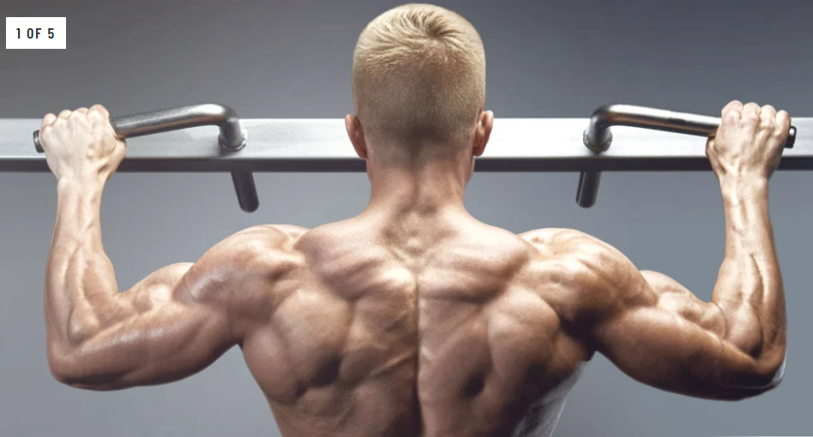

**This old school exercise has been used for generations by some of the biggest, baddest men around. Wide grip pull-ups are one of the best back exercises you can do, and they hit the lats especially hard. Grip the pull-up bar with an extra wide grip and hands pronated (palms facing out). As you do your pull-up, keep your elbows flared out, so you minimize bicep involvement and maximize lat activation.**

**As you get stronger in this movement, try adding weight with a pull-up belt.**

**5.Pendlay row**

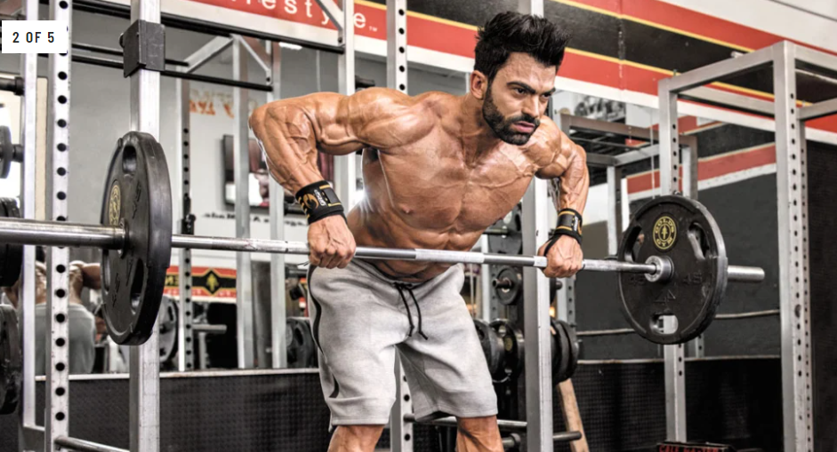

**I personally like to use the Pendlay row. When done properly it activates the lats more thoroughly than any other rowing movement. Technique is key when doing Pendlay rows, a lot of beginners turn this beautiful back exercise into some kind of bastardized bicep workout.**

**In a bent over position (knees bent, feet shoulder width apart, and back parallel to the ground) grab the bar around the same grip position as your bench press. Pull the bar off the floor to the upper abs. While doing this you want to keep your knees bent and hip angle locked in. There should be no movement of the hips or knees. Return the bar to the floor, pause, and continue. Make sure to consciously think about using your lats to pull the bar up and then squeezing your scapulae together at the top.**

## 6. Straight-Arm Lat Pushdown

## 

## Grab the straight bar attachment with both hands, palms facing the floor. Push your hands down in a sweeping arc motion, taking care to really emphasize the lats doing the work.

## 7. V-Bar Sternum Pull-Up

## 

**This is inspired by the great Vince Gironda, a pioneer in bodybuilding. This is a brutal variation of the classic pull-up. To perform this exercise get the v-bar attachment and put it over the pull-up bar so that one handle is on each side of the pull-up bar. Hold on to the v-bar and let the body hang. Next perform a pull-up, but instead of getting your chin over the bar you are going to pull yourself up so that the v-bar touches your sternum. This will require you to lean back at the top.**

## 8. One-Arm Lat Pulldown

## 

**Working one side at a time, or unilaterally, is a great way to increase muscle mass and muscular balance. Set yourself up on the lat pulldown machine with the handle grip attached. Grab the handle with one hand and pull it down to your front delt. Hold in the contracted position for a second and then return to the starting position.**

**9.Front squat**

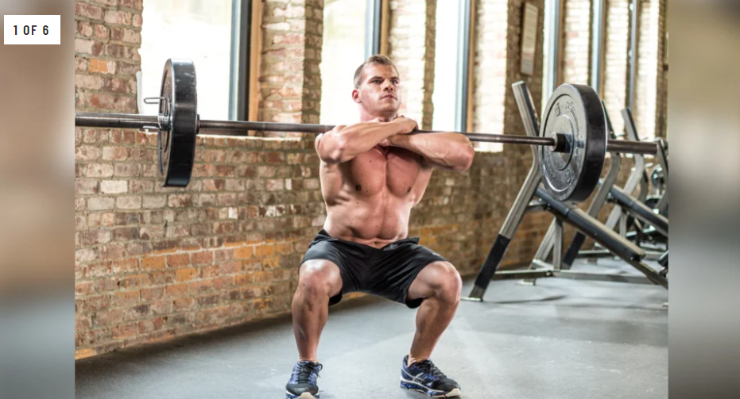

**The front squat makes you keep an upright torso position (so the bar doesn’t fall off your shoulders) this puts much more of the focus on your quads. Also, because of the upright torso, your knees will track forward over your toes.**

**This leads to a greater tibia angle and a more quad-dominant exercise.**

**10.Safety bar squat**

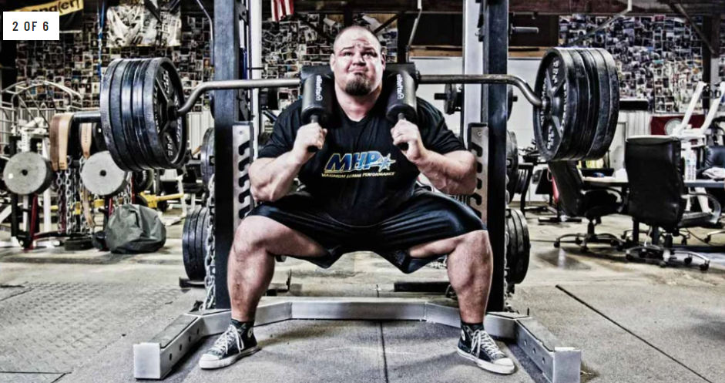

**Take the safety squat bar (the one with the pad and handles) and turn it backwards, so that the pads are in the front rather than the back.**

**Using this bar is great for people who have wrist mobility issues, or shoulder pain.**

**The camber of the bar also makes you stay more vertical, leading to more emphasis on the quads.**

**11.High bar heels elevated squat**

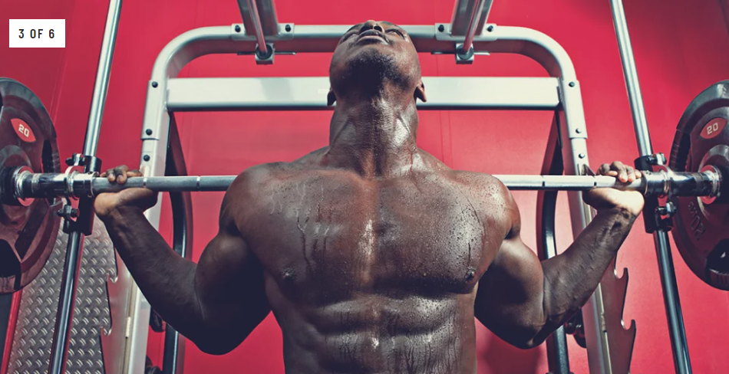

**This is a favorite of old-school bodybuilders.**

**For this squat variation, the bar will be up high on your traps and you will take a narrow stance with 25 lb. plates underneath your heels.**

**This will force your knees over your toes (increasing tibia angle) and allow your torso to stay upright, leading to a more quad dominant exercise.**

**This squat variation gets a bad rap, but for quad development it is highly useful.**

**12.Barbell stepups**

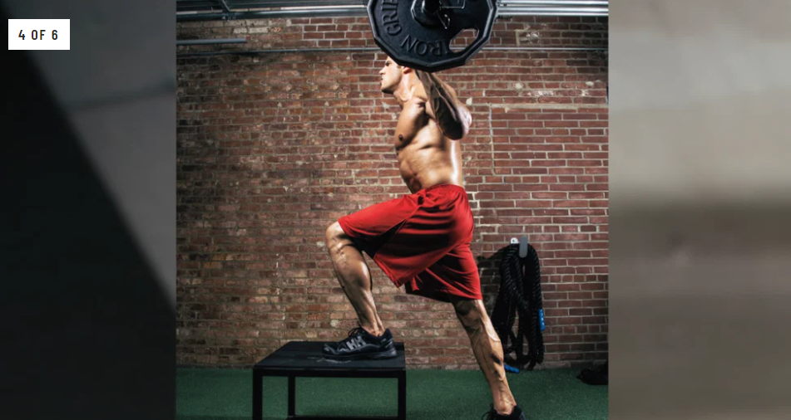

**To perform this lift, set up a box, bench or stack of plates to a height of 18-24”.**

**Put a loaded Barbell on your back and step up with your right foot.**

**Stand up on the bench by extending your hip and knee of your right leg and place left foot on bench. Step down with the left leg by flexing your hip and knee on your right leg.**

**Return to original standing position.**

**Start the next step up with your left leg, switching between right and left each rep.**

**13.Bulgarian split squat**

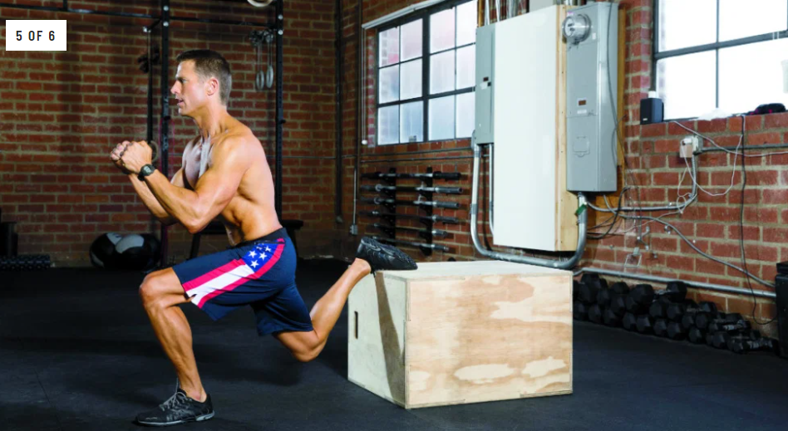

**Put the bar on your back like you are going to squat, put your back foot on a bench behind you and your front foot on the ground in front of you in a stretched out position (like a lunge.)**

**Now bend your front leg and squat down, continue down until the top of thigh is parallel to the ground.**

**Reverse the motion and stand up.**

**14.Leg extensions**

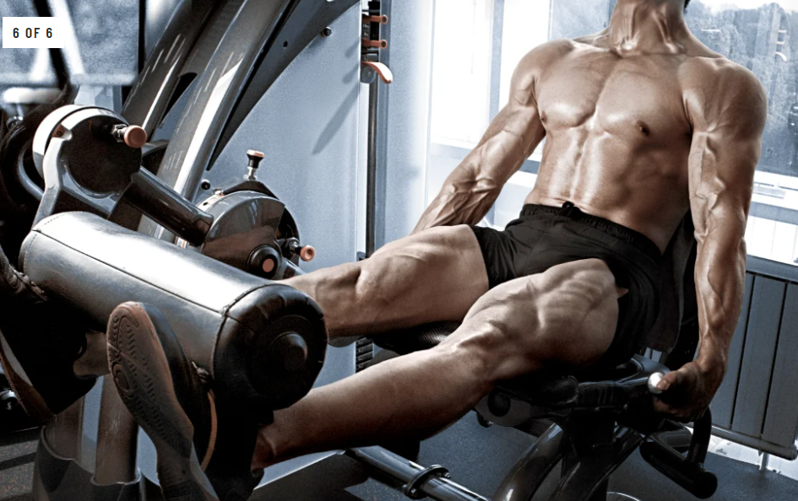

**The leg extension movement allows you to isolate the quadriceps better than any other exercise.**

**A toes-pointed-in position puts more stress on the outside sweep of the quads, while toes-pointed-out puts more stress on the inside of the leg and inner teardrop. The key is to bring the weight up as high as possible and hold it briefly at the topmost position.**

**A “muscle intention” style of lifting should be applied during the leg extension… feel those quads working and squeeze them hard at the top.**

**15. Land mine press**

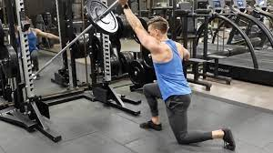

**The landmine press is a simple yet innovative movement designed to mainly target the upper portion of the chest muscles. To setup this exercise, place a standard Olympic barbell in the corner or on a landmine attachment while adding the appropriate amount of weight to the opposite end of the bar. Grab the weighted end with one hand and from a standing position, push the bar upwards. This will place extra emphasis on growing the upper portion of the chest.**

**16.Dip**

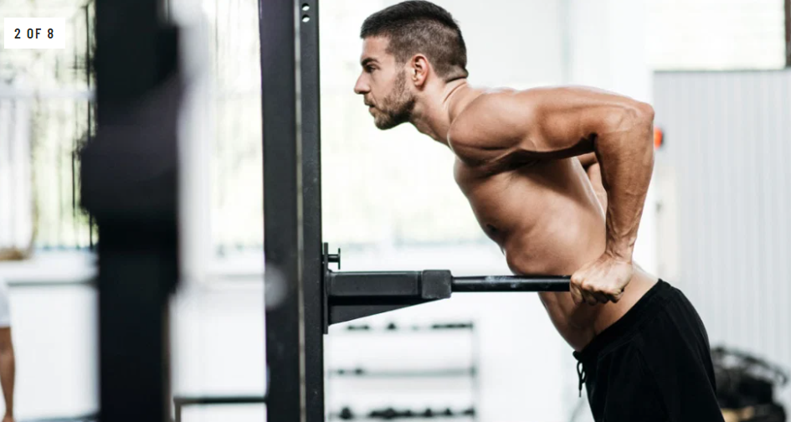

**Dips are basic, yet highly effective. Find the nearest dip station and grip the equipment with both hands slightly further apart than the conventional triceps dip. Concentrate on tilting your body downwards as opposed to upright to fully engage the chest muscles. All portions of the pec will be activated when performing this pec-targetted exercise.**

**17.cable crossover**

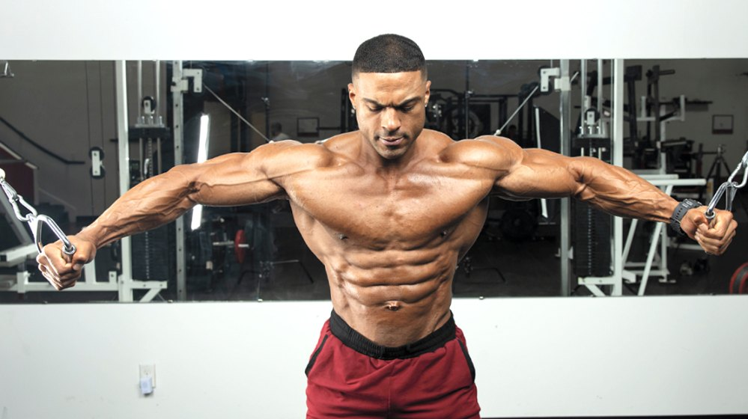

**The beauty of cable crossovers is the different variations you can use to hammer the chest muscles from a variety of angles. Place the cables in upright position to focus on upper chest development or place them near the ground for lower chest development. The difference between a crossover and a standard fly is the end of the movement. For the cable crossover, bring the arms towards each other forming an “X” shape at the end of each rep to stimulate the inner pectoral portion of the chest.**

**18.Pec fly machine**

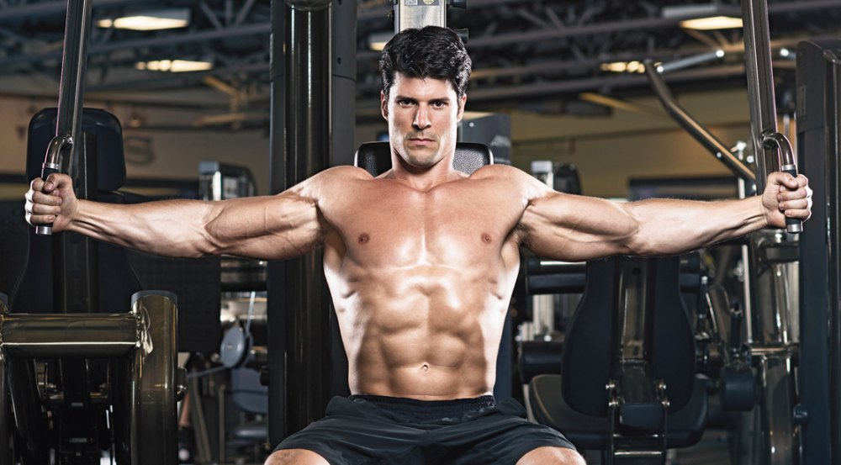

**One of the oldest yet most effective chest machines in gyms across the world is the pec fly machine. Use this as an accessory movement to really focus on hitting the pec muscles from all angles. While performing this pec variation try not to go too heavy and, instead, focus on making that ever so important mind/muscle connection. Squeeze at the center of the movement to really activate the inner portion of the chest. For a different move, you can try using one arm at a time for a unilateral pec fly variation.**